HIT Summer Course 2024

Artificial Intelligence and Machine Learning (22-26 July, 2024)

Individual Assignment
________________________________________________________________________________________
Out: Monday, 22 July., 2024 (Day 1)

Due: Thursday, 25 July, 2024 (Day 3)

Weight: 30% of the overall assessment ________________________________________________________________________________________________________________
Aims: This individual assignment is designed as an important component of the assessment of the subject. The purpose is to enhance your understanding of the fundamentals in AI and Machine Learning, in particular on the topics of intelligent search, reasoning and machine learning.

Part A (10 marks)
Suppose you are going to drive from city Arad to Bucharest according to the map below. The distance between two cities is marked in the graph. The heuristic information is shown as the straight-lined distance between any city to the target city. Please answer the following questions:

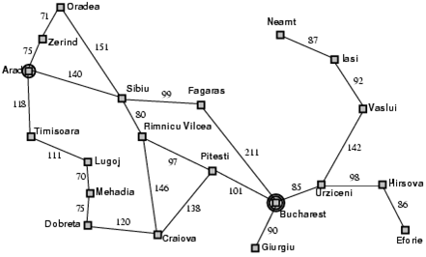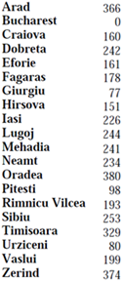

- Use transition model to formulate the problem and write down the initial state, goal state, solution, and give one example of transition model. (3 marks)
- Find the solution using breadth-first search algorithm and write down each step. (3 marks)
- Find the solution using A* search algorithm and write down each step. (4 marks)

Part B (10 marks)
Which of the following wffs (well-formed formula) are tautologies, which are contradictions, and which are neither? Please provide your answers with proper explanation. Be brief and concise.

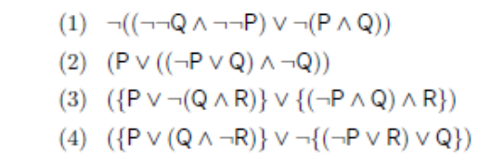

Part C (10 marks)
For the following dataset with binary classes (“yes” and “no”), please provide the detailed steps to build a decision tree by using ID3 algorithm.
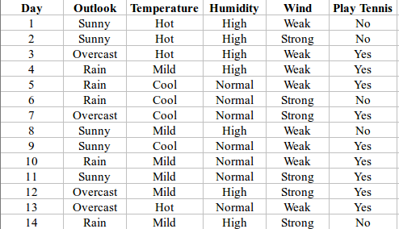

Assessment criteria:
- Clear steps and correct solution
- Penalty
-- 10% deduction for each day of late submission after the deadline;
-- no submission will be accepted after 2 days of the deadline without any justified reasons;
-- ZERO mark for any plagiarism found in the submission.

The submission
You are required to submit your completed work to Dr. Qince LI who will tell you how to make your submission before the deadline 26/07/2024 (11:55pm). Please name your file by your student ID, i.e, AI_assignment_ID.xxx, where ID is your student number; and the file format can be in either pdf or word .doc or .docx.

